**PS Lab 6**

Q1

i)

ii)



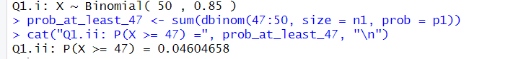

2)

i)





ii)





iii)

